The Principal,
Kashmir Government Polytechnic College,
Srinagar.

Subject: Joint requisition for supply of Switch & Socket Combinations required in respective departments.
Respected Madam,
We, the undersigned HOD’s/In-charges of various departments/sections, hereby jointly request you to kindly arrange for the supply of Switch & Socket Combinations required in our respective departments.
The department-wise requirement are as follows:
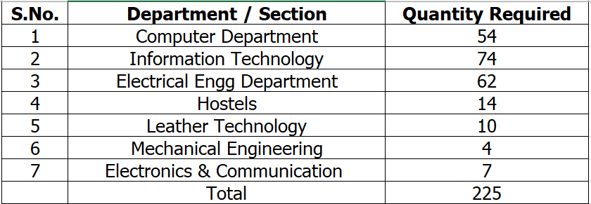
These Switch & Socket Combinations are urgently required for proper electrical wiring and safe operation of equipment in our respective departments/labs/hostel. We kindly request you to approve and forward this joint requisition to the Purchase / Stores / Electrical Maintenance section at the earliest for necessary procurement and supply.
Thanking you in anticipation.

Yours Faithfully
1.Incharge Computer Department
2.Incharge Information Technology
3.HOD Electrical Engg Department
4.Incharge Hostels
5.HOD Leather Technology
6.Incharge Mechanical Engineering
7. Incharge Electronics & Communication

